Module 9 – Generative AI

Name - Amrita Singh
Registration No – 49948841

Generative AI and NLP Programs using Hugging Face Transformers

Q1. Understanding Human Language using a Pre-trained AI Model (BERT)
Problem Statement:
You are given a short customer review like:
"The product is very good and easy to use."
The task is to use a pre-trained language model to understand how the computer processes this sentence.

Python Code
# Step 1: Install Required Libraries
!pip install transformers torch -q
# Step 2: Import Libraries
from transformers import BertTokenizer, BertModel
import torch
# Step 3: Load Pre-trained BERT Model and Tokenizer
print("Loading BERT tokenizer and model...")
tokenizer = BertTokenizer.from_pretrained('bert-base-uncased')
model = BertModel.from_pretrained('bert-base-uncased')
print("Model and tokenizer loaded successfully!\n")
# Step 4: Input Customer Review
text = "The product is very good and easy to use."
print("Original Sentence:")
print(text)
print("\n")
# Step 5: Tokenize the Sentence
tokens = tokenizer.tokenize(text)
print("Tokenized Words:")
print(tokens)
print("\n")
# Step 6: Convert Tokens into Token IDs
token_ids = tokenizer.convert_tokens_to_ids(tokens)
print("Token IDs:")
print(token_ids)
print("\n")
# Step 7: Encode the Complete Sentence
inputs = tokenizer(text, return_tensors="pt")
print("Encoded Input:")
print(inputs)
print("\n")
# Step 8: Run Forward Pass Through BERT Model
with torch.no_grad():
outputs = model(**inputs)
# Step 9: Inspect Model Output
print("Model Output Keys:")
print(outputs.keys())
print("\n")
last_hidden_state = outputs.last_hidden_state
print("Shape of Last Hidden State:")
print(last_hidden_state.shape)
print("\n")
print("Sample Output Vector for First Token:")
print(last_hidden_state[0][0])

Output
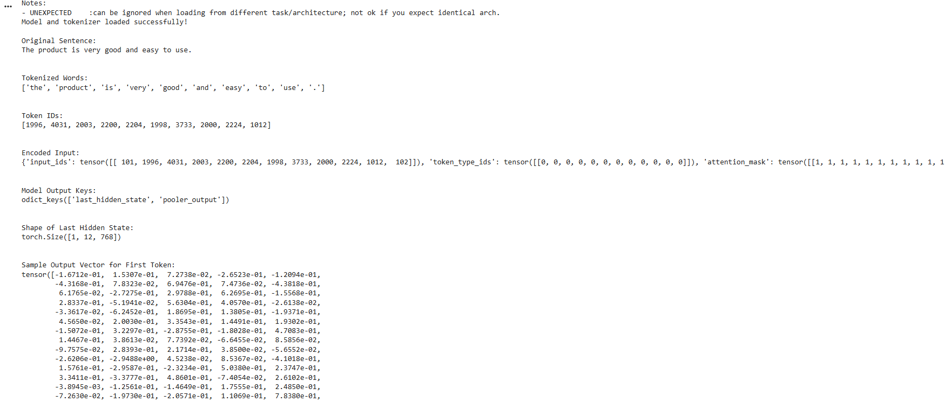

Q2. AI Writing Assistant using Generative AI
Problem Statement:
A company wants to build a simple AI writing assistant that can automatically generate text from a given sentence or topic using Generative AI and Hugging Face Transformers.

Python Code
# TASK 1: Install Required Libraries
!pip install transformers torch -q
# TASK 2: Import Required Libraries
from transformers import pipeline
# TASK 3: Load Pre-trained Text Generation Model
print("Loading AI Text Generation Model...\n")
generator = pipeline(
"text-generation",
model="gpt2"
)
print("Model Loaded Successfully!\n")
# TASK 4: Input a Starting Sentence
input_text = "Artificial Intelligence is"
print("Input Sentence:")
print(input_text)
print("\n")

# TASK 5: Generate Text Automatically
generated_output = generator(
input_text,
max_length=50,
num_return_sequences=1
)
print("Generated Text:\n")
print(generated_output[0]['generated_text'])
print("\n")
# TASK 6: Generate Text for Multiple Inputs
sentences = [
"Machine learning helps",
"The future of technology is",
"Python programming is"
]
print("Generating Text for Multiple Inputs...\n")
for sentence in sentences:
result = generator(
sentence,
max_length=40,
num_return_sequences=1
)
print("Input:", sentence)
print("Generated Output:")
print(result[0]['generated_text'])
print("\n")
print("-" * 60)

# TASK 7: Display and Interpret Results
print("\nInterpretation:")
print("The AI model predicts and generates new words")
print("based on the starting sentence provided.")
print("This is an example of Generative AI using")
print("a pre-trained Hugging Face Transformer model.")

Conclusion
These programs demonstrate how pre-trained AI models can understand and generate human language using Hugging Face Transformers.
Output
